AEPHY2022
Narrogin SHS Year 11 ATAR PHYSICS Name:
Task No: | 14
Task Type: | Test
Content: | Waves
Task Description: | Complete the attached questions in the spaces provided.  Marks will be awarded for presentation and working.  Test conditions (50 minutes).  Formulae and data booklet provided.  Non-programmable calculator permitted.
Total Marks: | 29
Weighting: | 6%
Materials required | pens, pencils (including coloured), sharpener, correction fluid, eraser, ruler, highlighters, scientific calculator
Due Date:

- Explain the difference between reflection, refraction and diffraction. Diagrams may be useful. (3 marks)

- Toby and Anisha are throwing stones, again! Anisha throws a stone into a pond, which lands 2m from the edge. After 5 seconds, 42 ripples have reached the edge of the pond. Calculate the wavelength, speed and frequency of the ripples. (6 marks)

- Draw a ray diagram for the following situation. (6 marks)

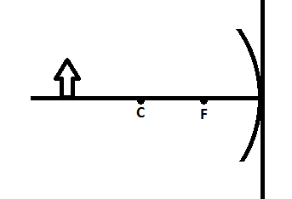Figure 2

Identify the nature of the image(circle): real / virtual

upright / inverted

enlarged / diminished

in front / behind mirror

- Leila and Jude are discussing an experiment to test the nature of sound waves. They imagine a loudspeaker with a dust particle sitting motionless in front of it, and consider what will happen to the particle when the speaker is turned on.
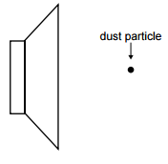Figure 3

Leila says that since there is energy transferred by the wave, the particle will gain energy. A succession of little impulses will push the particle continuously away from the speaker.
Jude agrees that energy is carried by the wave. However, the result of the pressure variations will cause the dust particle to move back and forth about its original position.
Who is most correct? Explain the logic of your choice. (2 marks)

- Byron and Oliver have a method for determining the speed of sound. Byron beats a drum at a rate of exactly two beats per second. Oliver then walks away from Byron along the street until the sound of the drum is heard at the precise instant Byron is seen to hit the drum. The distance from the drum to Oliver at this point is 167 m.
What is the calculated speed of sound? (2 marks)

- Figure 4 is a plot of the hearing sensitivity response of an average person. It represents the minimum sound intensity that can be heard as a function of frequency.
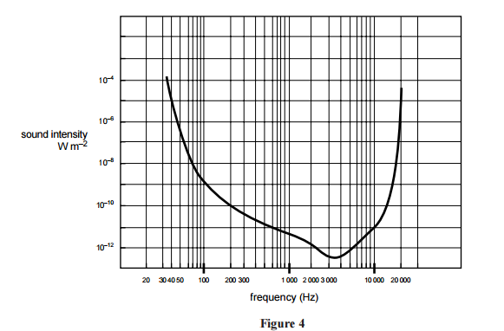

Gabrielle is listening to music with the volume of his stereo turned very high, such that the sound intensity at her ears is 10^{–5} W m^{–2} at a distance of 0.5 m from the speaker.

What are the lowest and highest frequencies that he can hear? (2 marks)

Lowest:

Highest:

Jacob tells her to move further away from the speaker, so Gabrielle moves to 2m from the speaker. What is the sound intensity at this distance? (2 marks)

- Liberty is playing a clarinet for Jude. A clarinet is a wind instrument that can be modelled as a tube closed at one end. Assume that the pressure nodes and antinodes occur exactly at the end of the tube.
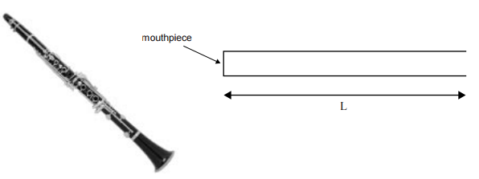Figure 5

The clarinet has a fundamental frequency of 130 Hz. The speed of sound in air is 340 m s^{–1}.
What is the length (L) of the tube that models the clarinet? (2 marks)

Jude now plays for Liberty, to produce the overtone at 650 Hz.
Which of the figures below (A–E) best represents the standing pressure wave in the tube that models the clarinet? (2 marks)

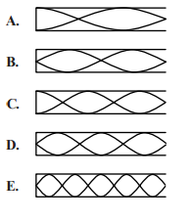

END OF TEST TOTAL: _____/29 MARKS

